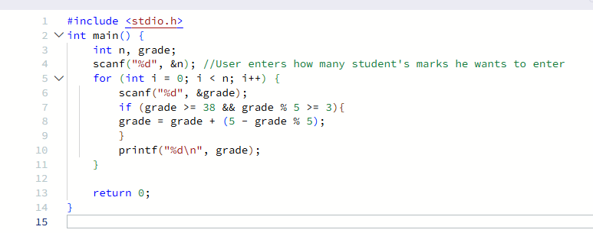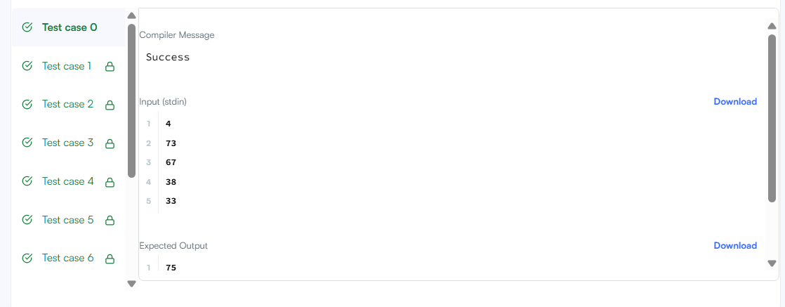
#include <stdio.h>
int main() {
int n, grade;
scanf("%d", &n); //User enters how many student's marks he wants to enter
for (int i = 0; i < n; i++) {
scanf("%d", &grade);
if (grade >= 38 && grade % 5 >= 3){
grade = grade + (5 - grade % 5);
}
printf("%d\n", grade);
}

return 0;}

